**Job Shadowing program example – Predict CSD Consulting**

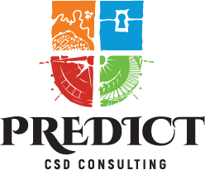

Day 1: Welcome and Introduction

Session 1

General Presentation of PREDICT CC

Introduction to the Week's Agenda

Session 2

Ice-breaker Activity and Networking

Session 3

VET Centre Visit #1

Tour

Meeting with Colleagues

Observing Classes

Session 4

Summary and Reflection on Day 1 Activities

**Day 2: VET Centre Exposure**

Session 1

VET Centre Visit #2

Tour

Meeting with Colleagues

Observing Classes

Session 2

VET Centre Visit #3

Tour

Meeting with Colleagues

Observing Classes

Session 3

Company Visit #1

Tour

Employee Interaction

Session 4

Summary and Reflection on Day 2 Activities

Day 3: Industry Exposure

Session 1

Company Visit #2

Tour

Employee Interaction

Session 2

Company Visit #3

Tour

Employee Interaction

Session 3

Workshop: Introduction to Graphic Design Basics for Educators (Part 1)

Basic Design Theory

Session 4

Summary and Reflection on Day 3 Activities

Day 4: Hands-on Workshop and Practical Application

Session 1

Workshop: Graphic Design Basics for Educators (Part 2)

Canva Fundamentals

Session 2

Workshop Project: Creating a Mood Board and a Facebook Cover

Session 3

Workshop: Graphic Design Basics for Educators (Part 3)

Photopea Fundamentals

Session 4

Workshop Project: Creating an Instagram Story and a YouTube Thumbnail

Day 5: Consolidation and Reflection

Session 1

Workshop Project: Creating a Facebook Post and a Printable Poster

Review and Feedback Session

Session 2

Group Discussion: Reflection, Lessons Learned, and How to Apply Knowledge

Session 3

Leisure Activity: Exploring the Local Area or Cultural Visit

Session 4

Final Roundtable: Q&A, Certificates Ceremony, and Farewell

**Graphic Design Basics for Educators Using Free Software course**

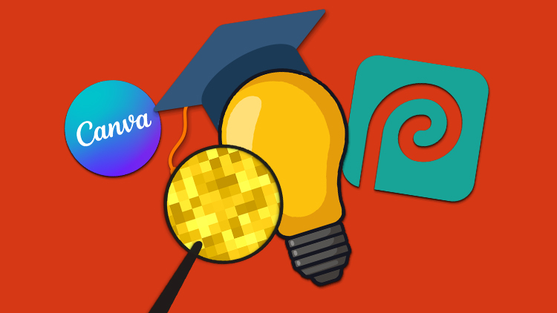

**What will you learn?**

● You will discover some of the best sources of inspiration professional designers use for their projects.

● You will have basic knowledge of graphic design theory that you will be able to recognize and apply.

● You will learn the fundamentals of Canva and be able to create suitable designs for social media platforms.

● You will be able to apply an easy-to-follow workflow from creating a moodboard to multiple designs

● You will learn the fundamentals of Photopea and get to know some impactful features that will enable you to create great looking artwork.

**Short description**

We've structured this course into two main sections: first, we will go through basic design theory, focusing on research and the principles of graphic design and secondly, we will get into actual design work using Canva and Photopea.

If your field of activity assumes communication, I won't need to tell you about just how important it is for your materials to look neat. You don’t need, however to necessarily externalize work to professional designers – with the help of this course, you can save a lot of energy and resources!

**Why should you choose this course?**

This course will help you get started with two of the best free software available and then provide you with a fast, no non-sense workflow from scratch to ready-to-publish designs. Also in Part 1, you will get briefed on the principles that make good design, as well as an easy-to-understand explanation on the two types of digital image.

Here are **the projects** followed through within this course:

* A Mood Board
* A Facebook Cover
* A Facebook Post
* An Instagram Story
* A YouTube Thumbnail
* A Printable Poster